NAME: _____JACKSON LIN______

UNIT 5 MINI PROJECT

Create an Insurance Database

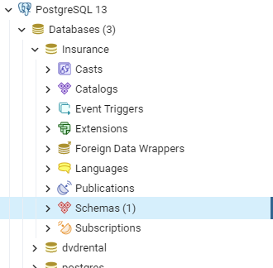

Create Insurance Tables

CREATE TABLE claim

(

Claim_ID_Number bigserial NOT NULL,

Claim_Receipt_Date date,

Claim_Description text,

Claimant_Birth_Date date,

Law_Suit_Indicator boolean,

Claimant_First_Name text NOT NULL,

Claimant_Last_Name text NOT NULL,

Policy_Number text,

Claimant_Occupation text,

Loss_Date date,

Claim_Amount money,

Claim_Paid_Amount money,

Claim_Paid_Date date

PRIMARY KEY (Claim_ID_Number)

);

CREATE TABLE public.Customer(

Customer_ID_Number bigserial,

Customer_First_Name text,

Customer_Last_Name text,

Customer_Type text,

Business_Name text,

Address_Street_Name_Line_One text,

Address_Street_Name_Line_Two text,

Address_City text,

Address_State text,

Address_Postal_Code int,

Address_Type text,

Customer_Birth_Date text,

Risk_Score int,

PRIMARY KEY (Customer_ID_Number)

);

CREATE TABLE public.policy_detail(

Customer_ID_Number bigserial,

Policy_Number text,

Policy_Effective_Date text,

Policy_Expiration_Date text,

Policy_Limit money,

Policy_Type text,

Currency_Type text,

Premium_Cost money,

PRIMARY KEY (Policy_Number)

);

CREATE TABLE public.Reserves(

Customer_ID_Number text,

Policy_Number text,

Reserved_Amount money NOT NULL,

Reserved_Date text

);

SELECT * FROM customer;

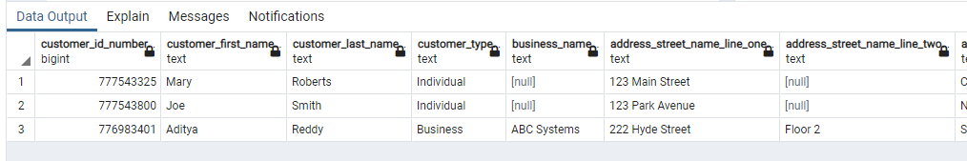

SELECT * FROM claim

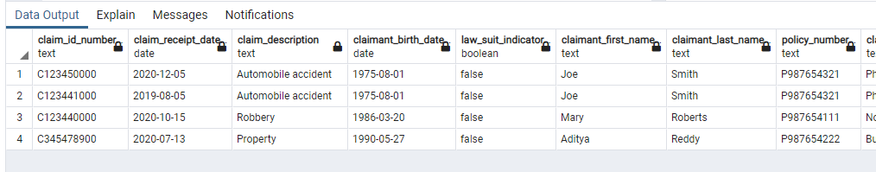

SELECT * FROM policy_detail;

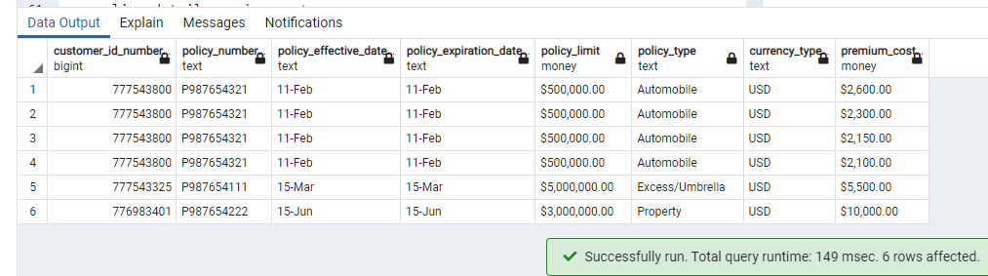

SELECT * FROM reserves;

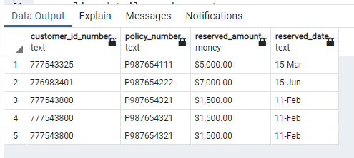

|  |  |  |
| --- | --- | --- |
| **TABLE** | **PRIMARY KEYS** | **FOREIGN KEYS** |
| Claim | Claim_ID_Number | Policy_Number |
| Customer | Customer_ID_Number | n/a |
| Policy_Details | Policy_Number | Customer_ID_Number |
| Reserves | n/a | Customer_ID_Number, Policy_Number |

Form any 5 SQL to extract information from tables:

SELECT * FROM customer WHERE customer_type = 'Individual';

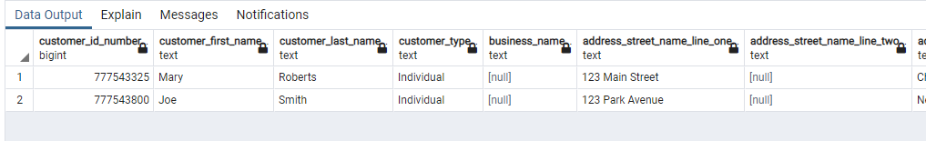

SELECT COUNT(*) FROM customer WHERE customer_type = 'Business';

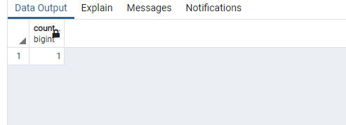

SELECT DISTINCT

policy_detail.policy_number,

policy_detail.premium_cost,

reserves.reserved_amount

FROM policy_detail

INNER JOIN reserves

ON policy_detail.policy_number = reserves.policy_number;

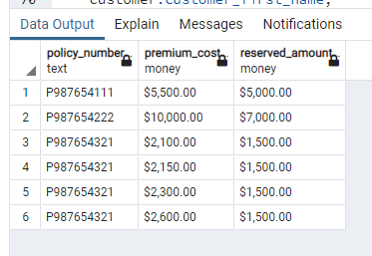

SELECT DISTINCT

claim.claim_id_number,

policy_detail.policy_number,

customer.customer_first_name,

customer.customer_last_name,

claim.claim_amount,

claim.claim_paid_amount

FROM claim

LEFT JOIN policy_detail

ON claim.policy_number = policy_detail.policy_number

LEFT JOIN customer

ON customer.customer_id_number = policy_detail.customer_id_number;

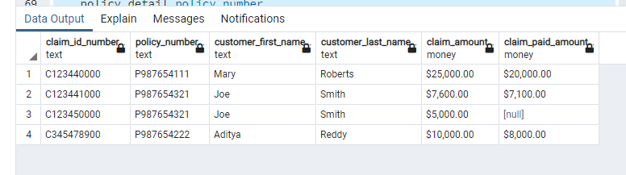

SELECT DISTINCT

policy_detail.customer_id_number,

policy_detail.policy_number,

policy_detail.policy_effective_date,

policy_detail.policy_limit,

policy_detail.policy_type,

policy_detail.premium_cost,

reserves.reserved_amount,

reserves.reserved_date

FROM policy_detail

INNER JOIN reserves

ON policy_detail.policy_number = reserves.policy_number;

